Underlay PUR 1.0 for ROCKO Flooring by Kronospan
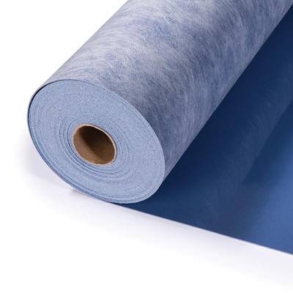
Material
PET film + polyurethane heavy-duty layer + non-woven material
Width
1.0 m
Length
10 m
Thickness
1.0 mm
Item No. [Customer Code]
98535 [EX PUR1.0_SPC]
Thermal resistance
0,007 ㎡ K/W
Walking sound reduction
13%
Impact sound reduction
11-15 dB
Durability
> 1000 kPa
Dynamic load
> 3.000.000 Cycles
Unevenness smoothing
0.2 mm
Moisture protection
-
Suitable for
1 mm thick acoustic underlay specifically designed for floating floors, also suitable for laminate, cork and parquet flooring.

